Operations/Work/Job Activity covered by this assessment: Grinding Machine
Required Personal Protective Equipment (PPE) :

Safety glasses must be worn at times. |   Long and loose hair must be contained.
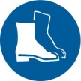  Appropriate footwear with substantial uppers must be worn. |   Close fitting/protective clothing to cover arms and legs must be worn.
Respiratory protection devices required. | 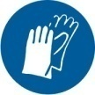  Oil free leather gloves and spats must be worn.

Hearing protection must be used when using this machine.

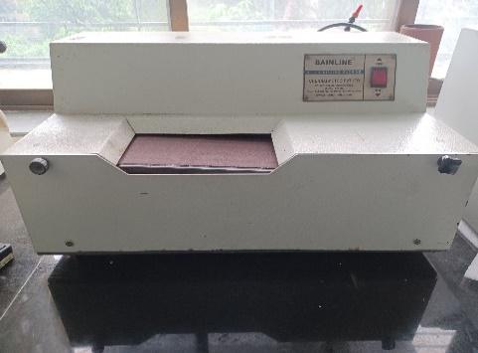
- After releasing the mounted specimen from Bain-Mount machine, clean the same with soap solution and the with running water.
- Dry the specimen with good quality filter paper
- With suitable engraver, put the specimen details on the backside of the mount so that it is parallel to the length of the specimen mounted.
- Open the front cover and ensure that the Emery paper with Grit 80 is held firmly between the two rollers in the equipment
- Close the front cover and switch ON the grinding machine.
- Wear the proper fitting gloves on your hand.
- When the emery starts rotating, hold the specimen as shown and start pressing against the rolling emery paper.
- After few seconds viz., 20-30 secs, immerse the specimen in cold water or coolant kept in a beaker nearby and then remove the water on the specimen by drying with filter paper.
- Repeat the process detailed in S.No.
- The grinding process is over once the grinding lines are parallel and uniform over the entire length of the specimen

